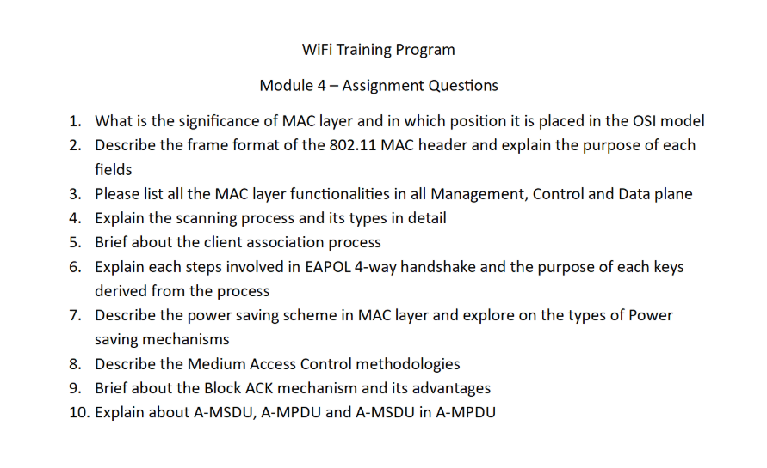
Wi-Fi Training Program
Assignment – Module 4

1. Significance of MAC Layer and its Position in OSI Model
The MAC (Media Access Control) layer is a sublayer of the Data Link Layer (Layer 2) in the OSI model, sitting above the Physical layer.
Significance:
- Controls access to the shared wireless medium (air)
- Provides MAC addressing for device identification
- Handles frame encapsulation and decapsulation
- Ensures reliable delivery using acknowledgments and retransmissions
- Manages collision avoidance using CSMA/CA
Explanation:
Unlike wired networks, wireless devices cannot detect collisions easily. Therefore, the MAC layer plays a critical role in coordinating transmissions and avoiding conflicts, ensuring efficient communication in a shared environment.

2. Frame Format of 802.11 MAC Header
The 802.11 MAC frame is more complex than Ethernet due to wireless requirements.
Main Fields:
- Frame Control (2 bytes):
  - Contains protocol version, frame type (Management, Control, Data), subtype, and flags (To DS, From DS, Retry, Power Management)
- Duration/ID (2 bytes):
  - Indicates how long the medium will be reserved (used in NAV)
- Address Fields (4 addresses possible):
  - Receiver Address (RA)
  - Transmitter Address (TA)
  - Source Address (SA)
  - Destination Address (DA)
  - BSSID (identifies the network)
- Sequence Control (2 bytes):
  - Handles sequencing and fragmentation
- Frame Body:
  - Carries actual payload (data or management info)
- FCS (4 bytes):
  - Error detection using CRC
Explanation:
Multiple address fields are used because frames may pass through APs, requiring both original and intermediate addressing.

3. MAC Layer Functionalities (Management, Control, Data Planes)
Management Plane:
- Network discovery (scanning)
- Authentication and deauthentication
- Association and reassociation
- Beacon transmission
Control Plane:
- ACK and Block ACK
- RTS/CTS (collision avoidance)
- NAV management
- Power save signaling
Data Plane:
- Data transmission between devices
- QoS handling (priority traffic)
- Frame aggregation (A-MSDU, A-MPDU)
- Retransmissions for reliability
Explanation:
Separating functionalities into planes improves organization and allows efficient handling of different network operations.

4. Scanning Process and Types
Scanning allows a client to discover available Wi-Fi networks.
Types of Scanning:
- Passive Scanning:
  - Client listens for beacon frames sent periodically by APs
  - No transmission from client
  - Lower power consumption but slower
- Active Scanning:
  - Client sends Probe Request frames
  - AP responds with Probe Response
  - Faster but consumes more power
Detailed Process:
- Client scans available channels
- Collects information (SSID, signal strength, security)
- Builds list of available networks
- Selects best AP based on signal and policy
Explanation:
Active scanning is commonly used in modern devices for faster connectivity.

5. Client Association Process
The process of connecting a client to an AP involves:
- Scanning: Discover available APs
- Authentication:
  - Open authentication or secure authentication
- Association:
  - Client sends Association Request
  - AP responds with Association Response
- IP Configuration:
  - DHCP assigns IP address
Explanation:
Association establishes a logical connection and allows the AP to track and manage the client.

6. EAPOL 4-Way Handshake
The EAPOL (Extensible Authentication Protocol over LAN) 4-way handshake is used to establish secure encryption keys in WPA2/WPA3.
Steps:
- Message 1 (AP → Client):
  - Sends ANonce (random number)
- Message 2 (Client → AP):
  - Generates SNonce
  - Creates PTK using PMK, ANonce, SNonce
  - Sends SNonce
- Message 3 (AP → Client):
  - Verifies PTK
  - Sends GTK (group key)
- Message 4 (Client → AP):
  - Confirms installation of keys
Keys:
- PMK: Master key
- PTK: Used for unicast encryption
- GTK: Used for broadcast traffic
Explanation:
The handshake ensures secure key exchange without exposing sensitive information.

7. Power Saving Mechanisms in MAC Layer
Power saving is critical for battery-operated devices.
Mechanisms:
- Legacy Power Save:
  - Client enters sleep mode
  - AP buffers data
  - Client wakes periodically to receive data
- U-APSD (WMM Power Save):
  - Efficient delivery using trigger frames
  - Reduces latency and power usage
- TWT (Target Wake Time):
  - Devices negotiate wake/sleep schedule
  - Improves efficiency in dense networks
Explanation:
Modern mechanisms like TWT significantly improve battery life and network efficiency.

8. Medium Access Control Methodologies
Primary Method: CSMA/CA
Steps:
- Listen to channel
- If idle → transmit
- If busy → wait and apply backoff timer
- Transmit after timer expires
Additional Techniques:
- RTS/CTS: Reduces hidden node problem
- NAV: Virtual carrier sensing
Explanation:
CSMA/CA avoids collisions rather than detecting them, making it suitable for wireless environments.

9. Block ACK Mechanism
Block ACK improves efficiency by acknowledging multiple frames at once.
Process:
- Sender transmits multiple frames
- Receiver sends single Block ACK
Advantages:
- Reduces overhead
- Improves throughput
- Essential for high-speed Wi-Fi
Explanation:
This mechanism is widely used in modern Wi-Fi standards for performance optimization.

10. A-MSDU, A-MPDU and A-MSDU in A-MPDU
A-MSDU (Aggregation at higher layer):
- Combines multiple MSDUs into one frame
- Lower overhead but less error resilience
A-MPDU (Aggregation at PHY/MAC level):
- Combines multiple MPDUs
- Each frame has its own error check
A-MSDU in A-MPDU:
- Nested aggregation
- Maximizes efficiency
Explanation:
Aggregation reduces protocol overhead and increases throughput, especially in high-speed networks.

